multiThreshold user’s manual
October 2011

Ray Meddis,

Department of Psychology, University of Essex,
Colchester, UK. CO7 9SW, rmeddis@essex.ac.uk

Distribution
This software is freely shared on the understanding that the recipient accepts full responsibility for how it is used and agrees not to redistribute it in any form. The author makes no guarantees of any kind by sharing this software. If you know someone who wants a copy, please refer them to the author who will send them the latest version of the software. Otherwise, old versions circulate to the detriment of our reputation!

Acknowledgements
While I am responsible for any bugs in the software, much of the development work associated with multiThreshold took place as part of the PhD studies of Wendy Lecluyse, Christine Tan and Manasa Panda. Without their help and the support of the charities ‘Deafness Research UK’ and’ Action on Hearing Loss’ and the Department of Psychology at the University of Essex, this software would never have happened.

Introduction.
MultiThreshold is a software tool for measuring a range of clinically relevant psychophysical thresholds quickly and painlessly. It has been designed around research activities in the Essex Hearing Laboratory using volunteers with a range of different hearing impairments.

A separate document with the file name ‘multiThreshold quickStart instructions’ is intended as a useful primer and should be used before reading this manual which is essentially technical in nature.

MultiThreshold is part of a much larger package (MAP1_14) that includes auditory modelling software. The MultiThreshold program has been designed so that it can evaluate a computer model of a patient’s hearing as well as measuring the patient’s hearing itself. This document is concerned purely with measuring the hearing of a patient.

Absolute thresholds, frequency-selectivity and compression
The software can be used in many different ways in the laboratory for psychophysical measurements but the primary motivation for its development concerned the in-depth evaluation of impaired hearing. The aim is to go beyond the audiogram to evaluate other dimensions of hearing, particularly frequency-selectivity and compression. The two figures below show profiles of two individuals; one with very good hearing (left) and one with impaired hearing (right). The continuous lines in the lower panel show the absolute thresholds for 250- and 16-ms tones at 250, 500, 1000, 2000, 4000 and 8000 Hz. The V-shaped functions indicate frequency-selectivity and the upper row of panels are intended to reflect compression at the same frequencies. These profiles were measured using multiThreshold.

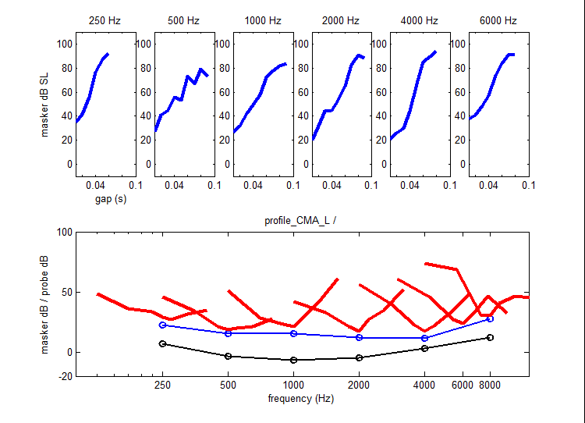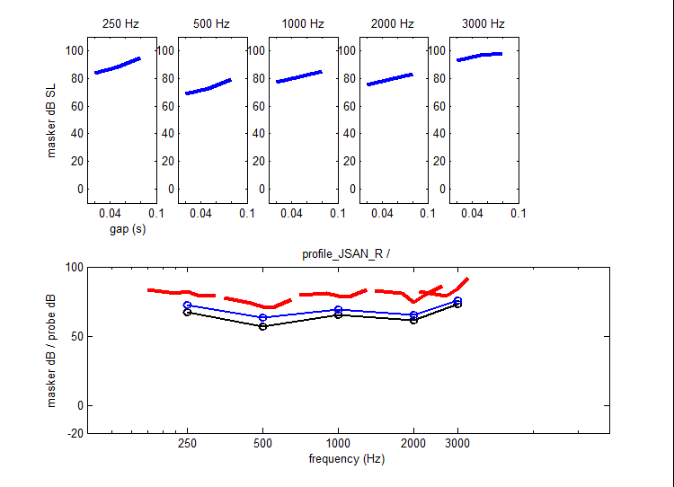

Making these measurements using traditional laboratory techniques such as two-alternative forced choice procedures would be very time consuming. It may not even be possible with some elderly patients who form the majority of people with a hearing impairment. To this end we have developed the cued, single-interval measurement method which is the method used to illustrate this manual. In our experience, patients are very tolerant of this technique and, at the time of writing, we have collected complete single-ear profiles from 60 patients.

A complete profile can be collected in about 2 hours of booth time. This is a short time by most laboratory standards but a long time by clinical standards. Complete profiles are therefore a luxury confined to the serious researcher of hearing impairment. Nevertheless, it is clear from the profiles above that much of the information in the profile is redundant and abbreviated profiles will be enough to get an insight into the nature of the patient’s problems. The optimum strategy for trading time spent measuring against insight gained is currently under investigation.

A second motivation for the development of multi-threshold was the need for a measurement protocol that could be used to test computer simulations of hearing impairment using exactly the same procedures as those used to test the patients. The modeling methodologies will be described in a separate document.

Software and hardware requirements
The software requires a MATLAB application (7.0 or later) and should work with any 24-bit sound card. It is assumed that the computer setup has an extension monitors visible to a patient in a sound-proof booth. It can be made to work with only one monitor but two is best.

The listener in the booth should have control of a mouse. Alternatively, a Cedrus button box can also be used to record responses. If a Cedrus box is present, the software will recognize it automatically.

The listener should be supplied with headphones connected to the sound card. multiThreshold will need to be calibrated for the headphones and sound system used. This is the responsibility of the user. Before trying the software, make sure that the output is not painfully loud!

Installation
The software package comes as a compressed folder called ‘MAP1_14’ which can be located anywhere on the hard disk of a PC. Unzip the folder to make it ready for use.

Getting started
To run the program:

- Open MATLAB
- Navigate to the folder ‘MAP1_14\multiThreshold 1.46’
- Run multiThresold by typing ‘run multiThreshold’ in the command window
- you should see the experimenter GUI
- To start measuring a threshold, type the patient’s name into the ‘name’ window (top centre of the experimenterGUI)
- Click on the red ‘run’ button
- This will now generate a second GUI for the patient
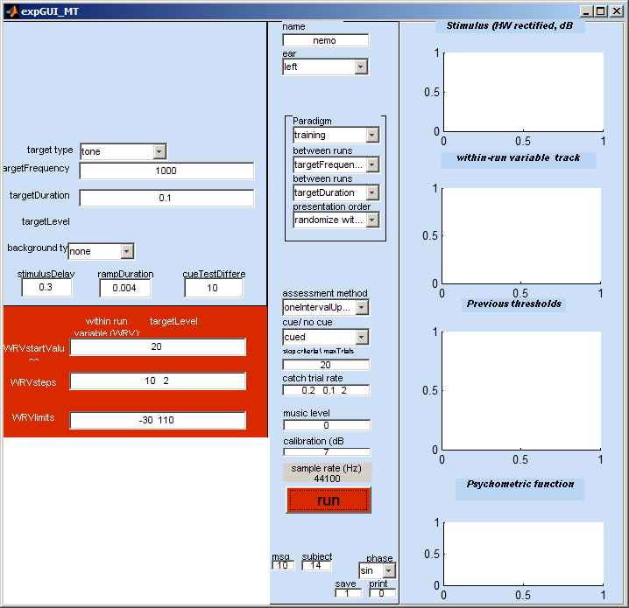 | 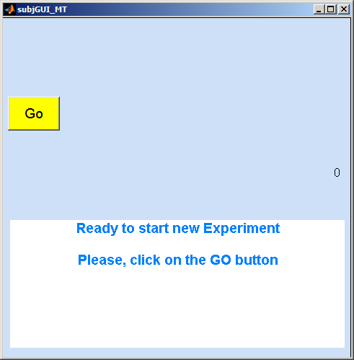
Experimenter GUI | patient GUI

General operating procedure
The patient GUI will always appear on the experimenter’s monitor at first. This must be dragged onto the patient’s own monitor if you have a two-screen system. This arrangement has the benefit that the GUI is not visible to the patient until the experimenter moves the GUI onto his monitor. This reduces the likelihood of a premature start.

By default the program starts in ‘training’ mode. It is set up to make a simple pure-tone threshold measurement at 1 kHz using a 100-ms tone stimulus.

The subject should be wearing headphones that are connected to the sound card of the computer. He initiates the measurements by clicking on the ‘Go’ button. One or two tones will be played approx 1 s later. When the tones have completed playing the subject GUI will change and will look like this.

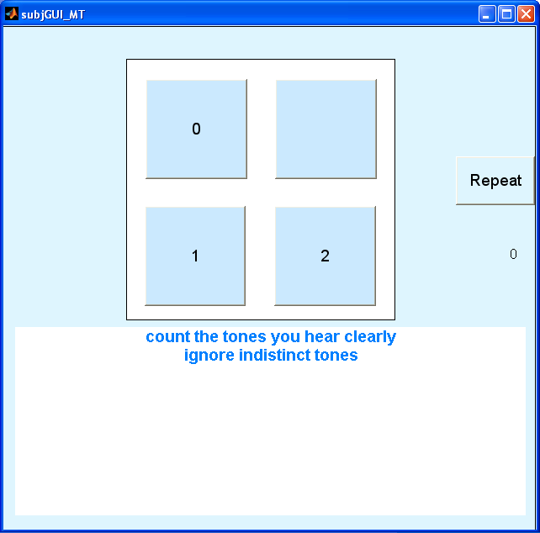

The patient must decide how many tones he hears and click on the appropriate button.

The next stimulus will be presented approximately 1 s later and the series will continue until the threshold measurement is complete. The patient will hear a ‘tada!’ sound when the run is at an end and the measurement is complete. A ‘Thank-you’ message will appear on the subject GUI.

Stopping
If, for any reason the experimenter wants to restart the experiment prematurely, he can do so by clicking on the ‘run’ button again. This resets everything and all previous data from the previous run(s) are abandoned.

At the end of the measurement, summary information will be printed in the MATLAB command window. A great deal of information about the measurement procedure is printed. In fact every variable and all results related to the measurement are printed out. Much of this can be ignored in everyday use but it can be vital when evaluating data retrospectively because it is a complete account of what happened. The most important information, e.g. thresholds, is printed both at the beginning and the end of the command window print out.

The print out is tab delimited and is particularly suited to pasting in Excel ready for summary figures to be produced.

At the head of the printout, you will find something like this:

******** multiThreshold version 1.46

Name: Meddis
paradigm: training
Ear: left
method: oneIntervalUpDown/ withCue
date: 10-Sep-2011 07_43_51

thresholds
targetFrequency/ targetDuration
0.1
1000 21.4713

The meaning of each element of this summary should become clear later.

Terminology
The following meanings are implied throughout the manual. Many of these can be found on the experimenter GUI.
Trial A single episode consisting of the presentation of a stimulus and the recording of a single patient response
Catch trial A trial when no target tone was presented
Run A complete sequence of trials used to estimate a threshold
Series A complete sequence of runs used to estimate a number of thresholds
Target A sound used to assess the patient’s hearing. All measurements are based on the detection (or failure to detect) a target. The target is sometimes called the ‘test tone’ or ‘probe’.

Target type A range of optional types of target can be used. The pure tone option is the default.

Masker A sound that may (or may not) alter the audibility of the target. The masker can be programmed to occur at any time relative to the target. A masker is used only in some paradigms.

Masker type A range of optional types of masker can be used. The pure tone option is the default.

Gap The time delay between the end of the masker and the beginning of the target. The gap can be negative if the target begins before the end of the masker

Test stimulus A target or masker-target combination used to assess threshold

Cue A sound or sounds that prepare the patient for a following test stimulus. Typically, in multiThreshold, the cue is similar to the test stimulus (e.g. a masker-target pair) but adjusted so that the target component is more audible. Only some paradigms use a cue

Cue-test Difference The adjustment applied to the test stimulus when designing the (more audible) cue stimulus; e.g. a more intense target or a less intense masker, depending on the paradigm

Ramp All tones have cosine-squared onset and offset ramps

Duration The time between the onset of a tone and its offset. The duration includes onset and offset ramp durations

Stimulus delay the delay between clicking on a response button and the onset of the next stimulus in the sequence. The delay can also be the time interval between the cue and the test stimulus

Background A sound that is played continuously through a single trial. The stimulus delay (see above) specifies the time interval between the onset of the background and the onset of the cue or test stimulus

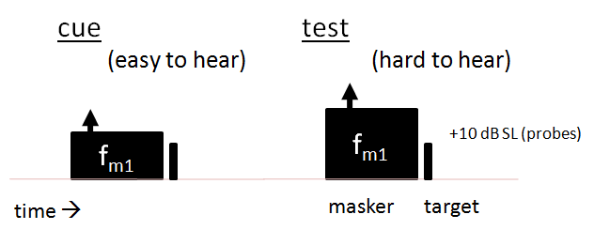
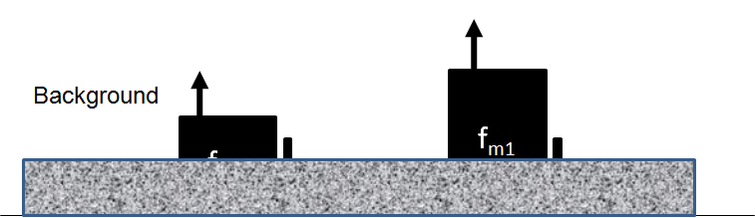

Top row: example of a stimulus used in a cued/single interval paradigm. Bottom row: example of top row with background sound added

Paradigm A completely specified measurement procedure

Within Runs Variable (WRV) A characteristic of the stimulus (e.g. target level, masker level) that changes adaptively) between trials. The WRV is defined by the paradigm

WRV track A sequence of levels used so far in the current run

Reversal A change in the direction of the WRV track

WRVsteps The size of the change of the WRV between trials. This typically has two values; the initial step size and the final step size. The initial step size applies before the first reversal and the final step size applies thereafter

WRVlimits The track is restricted to within these limits. If the next step will take the track outside of these limits, the run is aborted and the measurement reported as ‘NaN’ (not a number

Assessment method Four assessment procedures are available: 1) single interval up/ down, 2) maximum likelihood, 3) two-alternative forced choice (2 down one up) and 4) two-alternative forced choice (3 down one up). The principle procedure is single-interval up/down because this is most suitable for use with patients. This manual assumes that this procedure will be used. The other, more traditional, procedures are offered for users who are more familiar with them and may wish to compare them with then single-interval procedure. The single-interval up/down method can be presented with or without a cue.

The single-interval, up/down method is described in Lecluyse and Meddis (2009). A pdf version of this article is supplied in the MAP1_14\multiThreshold 1.46\documentation

Music level The level (dB) of the musical signatures (e.g. ‘tada!’) used to signal to the patient the end of a run or a series. This level is relative to a value clearly audible to subjects with normal hearing.

Experimenter GUI
The experimenter graphical user interface (GUI) can be used to define the stimulus and the testing procedure. It is also used to report back results while the testing is in progress. The definition of each measurement procedure requires a great deal of information. However, this can be supplied automatically by selecting a ‘paradigm’ from the paradigm popup menu in the central panel of the GUI. When a paradigm is selected, all of the boxes in the GUI are automatically filled. After selecting a paradigm, changes can be made to the values in the boxes.
The following account is aimed at users who wish to manipulate the details of a paradigm. It also explains the meaning of the graphics. The GUI is divided into three vertical panels. The meaning of their contents will be explained in turn. Some editable boxes are automatically rendered invisible when they are not appropriate to the current paradigm (e.g. when a masker is not used in the stimulus).
Stimulus parameters | Paradigm | graphics
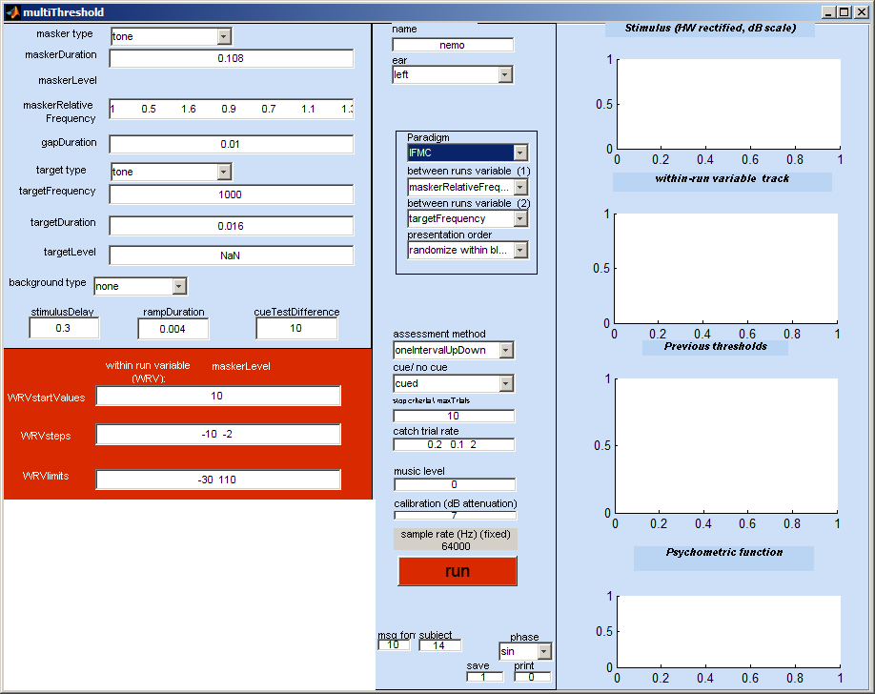 |  |  | Figure 1: current stimulus
 |  |  | Figure 2: levels track
 |  |  | Figure 3: previous thresholds
 |  |  | Figure 4: psychometric function

Stimulus parameters (left vertical panel)
The boxes to the left of the screen allow the user to change the stimulus parameters. The quantities in the boxes are in Hz, seconds or dB SPL ,as appropriate.

The description immediately below refers only to ‘cued/single-interval’ threshold estimation procedures.

The panel is divided into a blue zone and a red zone. The red zone contains the details of the within-runs variable (see above) while the blue zone gives the details of all other stimulus parameters. The box in the blue zone corresponding to the WRV is made invisible because it is continuously modified by the software except for its initial value which is set in the red zone.

Stimulus parameters (blue zone)
The meaning of these boxes should be self-evident when read in conjunction with the terminology section above.

Within-runs variable (WRV, red zone)
In any test run, there is one stimulus parameter that changes from trial to trial. This is called the ‘within runs variable’. The WRV is defined by the current paradigm. In the case of absolute threshold measurements, the WRV is, obviously, the level of the target tone.

The WRVstartValues box indicates the starting level of the target or masker. The starting value is selected randomly from trial to trial within the range +/- half of the large step size given in the WRVsteps box (see below).

The WRVsteps box controls the step sizes. When the patient reports having detected the stimulus, the level of the WRV will be changed adaptively to make the stimulus less audible. The amount by which it is raised or lowered is given in the WRVsteps box.

The default values for the training paradigm are, for example, ’10 2’. This means that the level will be changed in steps of 10 dB until the first reversal when the patient first changes his judgment from ‘yes’ to ‘no’ or vice-versa. After this ‘first reversal’ the level is set to the midpoint of the most recent ‘yes’ and ‘no’ responses. The procedure then continues with a reduced steps size of 2 dB.

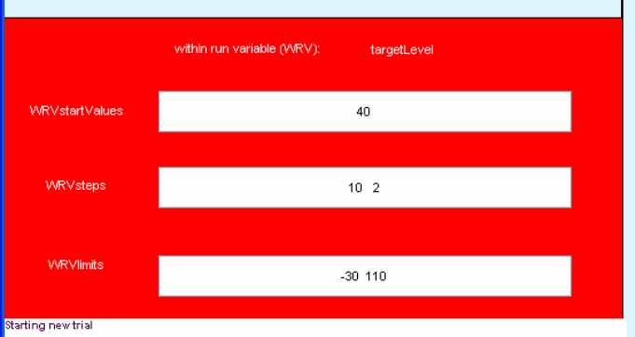

The WRVlimits box specifies the range of levels to be allowed. If the level moves outside of these limits, the program will abort this run and specify the threshold as ‘NaN’ (not a number in MATLAB speak).

Message panel
A white panel to the bottom-left of the experimenter GUI displays all of the subject responses, levels and threshold estimates in the current run.

Row 1: the subject response (1=detected, 0 = not detected).
Row 2: the corresponding level of the stimulus
Row 3: the current estimate of the threshold.

Other messages might be displayed here including warnings and reports of illegal parameter specifications.

At the end of a run, this information is replaced by a summary of the thresholds obtained.
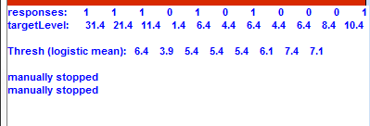 | 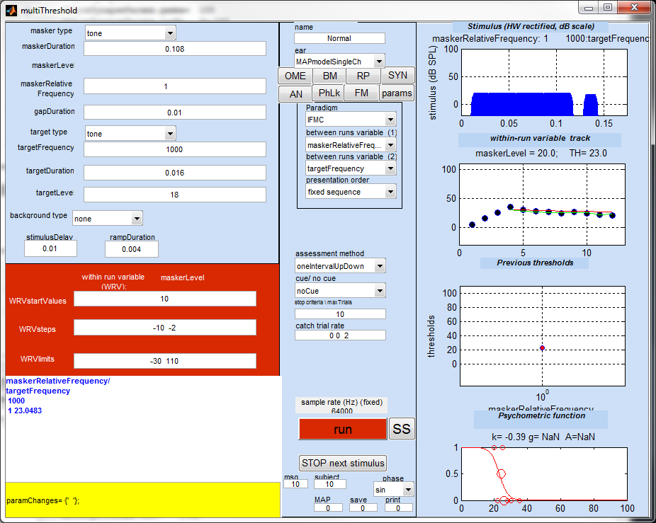

Paradigm settings (middle vertical panel)
The middle panel is used to set up the design characteristics of the measurements procedure.

Name
The experimenter must type the patient’s name here. It will be used in all printouts.

Ear
The second popup menu in the central panel selects the ear to be tested. In addition to left and right it is possible to select diotic presentation.

A dichotic option also exists but only applies to paradigms using a masker. ‘dichoticRight’ signifies that the target will be presented to the right ear while the masker will be presented to the left ear. ‘dichoticLeft’ is the converse.

The other options are related to modelling work. The auditory modeling (MAPmodel*) facilities are not explained in this manual but the statistical modeling facilities (statsModelLogistic, statsModelRareEvent) are described below.

Paradigm sub-panel
There are four popup menus (grouped together) used to define the kind of experiment required. These are described in more detail below.
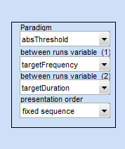

The first menu (Paradigm) is the most useful. When you select a paradigm the software will put appropriate values in all the boxes on the GUI for you. For regular testing, most users will often only be required to choose a paradigm from the list.

For clinical use, the paradigms of most interest are ‘training’, ‘absThreshold’, ‘absThreshold_16’, ‘TMC’ (for assessing compression) and ‘IFMC’ (for assessing frequency selectivity). Other paradigms are intended for laboratory use and for evaluation of computer models of hearing.

When a paradigm is selected, all of the boxes on the GUI are re-populated with new values that are the default parameters for that paradigm. These values are stored in paradigm files in the paradigms sub-folder of multiThreshold1.46. These can be modified as described below. The user can also create new paradigms that automatically fill the boxes. This facility is explained later.

Three other boxes are grouped with paradigm. These are mainly concerned with the control of the testing sequence when multiple measurements are made in a single series. They identify which variables are changed between runs and the order in which they are presented.

Assessment method
Various assessment methods are available (single interval up/down, maximum likelihood, two-interval forced choice (2AFC++, 2AFC+++) and these are explained below. For patient testing, we recommend the ‘single interval up/down’ method. The other options have more use in a laboratory setting.

Cue/ no cue
This gives the option of whether or not to play a cue stimulus before the test stimulus. The use of the cue is recommended because it produces the most sensitive measure of audibility. The ‘no cue’ condition is mainly used for modeling work.
In the no cue condition, the patient merely has to indicate ‘yes’ or ‘no’ whether the target has been heard. In the cued condition the patient is asked to count the number of targets. A ‘2’ response indicates that the test target was heard. This is equivalent to a ‘yes’ response. A response of ‘1’ indicates that only the cue target was heard. This is equivalent to a ‘no response.

Stop criteria \ max trials
Each stimulus presentation is called a ‘trial’. A run continues for a fixed number of trials after the first reversal. The value in this box sets the desired number of trials after the first reversal. The default value is set to 20 although in practice it will often be found that 10 trials give just as good a result. This is particularly true for patients with impaired hearing where the psychometric function is very steep and for whom very accurate measurements are not required.

If, at the end of the requested number of trials, the track is assessed as not yet close to threshold, the software automatically begins a new run of trials. This occurs is the track is continuously rising or falling, suggesting that it is in the wrong measurement region.

Guidance on the number of trials to use is given in the description of the single-interval, up/down method in Lecluyse and Meddis (2009). A pdf version of this article can be found in MAP1_14\multiThreshold 1.46\documentation.

Catch Trials
A fraction of the trials are ‘catch trials’. During a catch trial, no target is presented. If the patient responds ‘yes’ on a catch trial, the run is aborted and the patient must click on ‘Go’ to restart the run.

Patients should be instructed to respond ‘yes’ only when they are sure that they have heard the target tone. We have experienced no difficulty with this conservative approach when using patients and long error-free runs are normal. The matter is discussed in Lecluyse and Meddis (2009). Traditionalists often claim that this will lead to a biased estimate of the threshold but there is no experimental evidence to support this claim however self-evident it may seem to some.

The catch trial rate is set by two values in the ‘catch trial rate’ box. It may never be necessary to change this and the following is for information only. At the beginning of a run, the catch trial rate is the first number in the box. This is normally 0.2 and represents a 20% catch trial rate. If the patient is caught out, the rate is increased on the next run. The increase is in steps of 0.1 up to a maximum of 0.5. If he is not caught out on a run, the rate is reduced progressively to a minimum rate specified by the second value in the box (normally 0.1).

Catch trials never occur on the first trial of a run. Catch trials always occur on the second trial of a run. After that, they are distributed at random with no constraints. Catch trials serve to check that the patient understands the instructions. It is useful, therefore, that the first trial is always a regular trial and the second trial is always a catch trial. This gives early warning of a problem. However, the second catch trial gives the patient an exemplar of a stimulus when no target is present and this can be a useful reference. The subject is not informed of this first/second trial rule.

Music level
This value is used to increase or decrease the level of the musical signatures that indicate when a run or session is completed (‘tada!’). a default value of ‘0’ is adequate for listeners with normal hearing but may need to be increased for some patients.

Calibration
An attenuation of the output signal can be applied using the ‘calibration (dB attenuation)’ box. Ideally, your equipment should be set up so that an attenuation of 0 dB is appropriate. If this can be achieved, the maximum dynamic range of the sound system can be delivered starting at 1 microPascal and depending on the number of bits available from the sound card. For a 24-bit sound card this gives a 144 dB dynamic range starting at -28 dB SPL.

The program computes the signal as an integer vector specified in microPascals. This is the numeric value that is sent to the sound card. The calibration works by reducing the integer value sent to the sound card. To help visualize this, a 20-dB value in the calibration box will give a working range between -48 and 124 dB SPL for a 24-bit card.

Negative calibration values can also be used. If a negative calibration value is used, this boosts the signal but the dynamic range is still reduced because the highest values cause the sound card to ‘clip’.

Sample rate
The stimulus sample rate is fixed in the paradigm file (see below) and displayed on the experimenter GUI. The sample rate cannot be adjusted using the GUI but must be set using the paradigm file.

Run button
Clicking on the red ‘run’ button initiates (or restarts) a measurement session using the parameters on the GUI at the time the button is clicked. You can hit ‘run’ at any time. It should abort the current run (if any) and start with the current set of parameters.

Results sub-panel
The top right panel shows a graphical representation of the most recent stimulus (half-wave rectified and plotted on a vertical log scale). This allows the experimenter to see what is happening. The representation is a half-wave rectified version of the stimulus presented on a decibel scale.
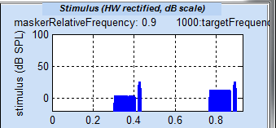
Results panel: stimulus display for a forward masking stimulus

The second panel shows the track, i.e. the sequence of the stimulus levels presented so far to the subject. The red line shows the running estimate of the threshold. The threshold estimated is updated after each trial. The threshold is the mean of the best-fit psychometric function to the data (see Lecluyse and Meddis, 2009).
Results panel: track of stimulus levels

The third panel shows all previous threshold estimates since hitting the <run> button.
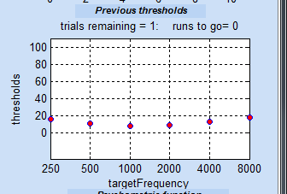
Results panel: summary of recent threshold measurements

In the fifth panel the red line is the best-fit (logistic) psychometric function to the data on this run. The small dots at the top and the bottom of the graph represent ‘yes’ (1) and ‘no’ (0) responses. The circles represent the proportion of ‘yes’ responses in a single 1-dB wide histogram bin. The size of the circle represents the proportion of responses included in the calculation. If a black line is also shown, this is the fit of a rival (‘rare event’) function of local interest to Essex Researchers.
Results panel: psychometric function of data points collected so far for this trial

Setting up an experiment
Every experiment is different and many parameters need to be established at the beginning of each session. MultiThreshold takes some of the labour out of this by setting default parameters for a range of stimulus paradigms. The first step in setting up an experiment should involve the selection of a paradigm from the paradigm pup-up menu in the central panel. This will automatically change all parameters to a reasonable starting value. These can then be changed to suit individual needs before beginning a session. The characteristics of each paradigm are described later.
The terminology used to describe an experiment has already been outlined above. Here are a few key reminders.

Multiple runs in one session
A single threshold measurement is called a ‘run’. Multiple runs are possible and, indeed, normal with MultiThreshold. To illustrate this process, select the ‘absolute threshold’ paradigm from the ‘Paradigm’ popup menu in the central panel. The targetFrequency box will now contain a number of different frequency values:

250 500 1000 2000 4000 8000

Clicking on the ‘run’ button will now initiate 7 threshold measurements in sequence. At the end of each measurement, the patient will be invited to click on the ‘Go’ button to initiate the next run.

Between -runs variables. Variables that change between runs (e.g. target frequency in a series of absolute threshold measurements) are called ‘between-runs variables’. Normally, there is only one between-runs variable but the system does allow for the possibility of two. These variables are identified in the two popup panels immediately below the paradigm popup menu.
Two variables are always specified even though one may not be used. This is because the second value is used in printouts. Normally, the user should ignore these menus as they are set automatically when a paradigm is selected from the paradigm popup menu. They can be useful, however, for certain advanced applications. The value of the second, unused, between runs variable is shown on the end of series printout in the command window. This can sometimes be useful in record keeping. In this example the printout shows that the duration of the target tone was 0.500s. This is important information because the absolute threshold varies with signal level.
Name: Ray Meddis
Ear: left
date: 09-Apr-2008 07_28_09
paradigm: absThreshold
thresholds
targetFrequency/ targetDuration 0.5
250 15.8862
500 8.1767
1000 8.2452
1001 6.9469
2000 4.0175
4000 13.3904
8000 12.0761

Figure 1. Subject GUI waiting to initiate a second run.
When two between-runs variables are specified, the second set of values will be changed more slowly. For example, if duration is the second between-runs variable, we might choose to use two durations 0.008 and 0.5 s. In this is the case, all measurements at 0.008 s will be made before those at 0.5 s. If both variables are used in this way, the final report will look like this.

******** multiThreshold version 1.29
Name: Meddis
Ear: left
date: 09-Apr-2008 07_38_51
paradigm: absThreshold
thresholds
targetFrequency/ targetDuration
0.008 0.5
250 39.3717 17.2477
500 26.0641 9.6303
1000 23.3528 6.86
1001 22.357 9.173
2000 19.3514 4.5804
4000 21.7742 10.7419
8000 29.5017 12.6421

The thresholds for the short duration target are in the second column and those for the long duration are in the end column. Note that all rows and columns are sorted into numerical order and do not represent the actual sequence of the trials.

Presentation order
The order of presentation of the runs can be fixed or randomized. Use the ‘presentation order’ popup menu to select an option.

The ‘fixed sequence’ option follows the order prescribed in the relevant stimulus parameter boxes; the second between-runs variable is the most slowly changing.

The ‘randomize within blocks’ option varies the second between-runs variable slowly in a fixed sequence but randomizes the sequence of the first between-runs variable.

The ‘randomize across blocks’ option presents the whole sequence in a random order.

multiThreshold expects only one value in a parameter box unless it is selected as a between-runs variable. Putting multiple values in a parameter box is a mistake and will cause an abort unless that parameter has been selected as a between-runs variable using one of the two popup menus.

The task
The patient’s task is to indicate whether or not he heard the target tone. This approach is commonly used in clinical situations. However, the method used to ask the question takes two forms depending on whether or not a cue is used.
No cue condition | Cued condition
Slower, easier task, more sensitive (most suitable for inexperienced observers) | Faster, less sensitive and can be confusing for inexperienced users
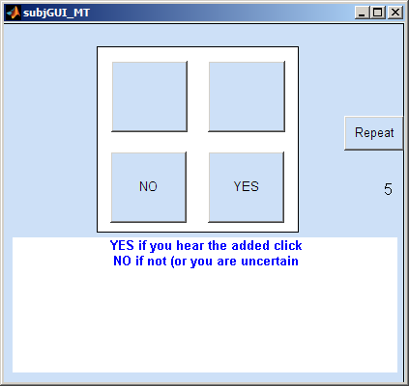 | 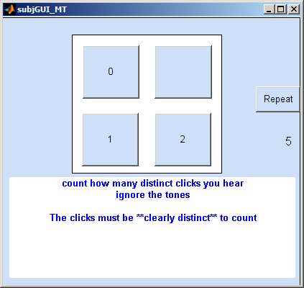
Subject GUI for cued (left) and uncued (right) tasks.
In the cued condition, either one or two target tones are presented and the listener is asked to count the number he heard. The subject GUI for this task is shown on the left. In the noCue condition, either no target or one target is presented and the patient simply indicates ‘yes’ or ‘no’. The noCue task is quicker and may appear to be simpler but it is more confusing for an untrained user (i.e. a typical patient) because of uncertainties that arise when no target is presented as in a catch trial or when the target is below threshold.
In the cued condition the presence of the cue on every trial simplifies the task and lowers thresholds by orienting the patient to the timing and nature of the target. In this condition the patient is asked to count the number of targets heard (‘1’ or ‘2’). Moreover, patients have little difficulty in grasping the concept of a counting task and this is recommended for clinical use.
It should be stressed to the patient that a ‘1’, ‘2’ or a ‘yes’ response should only be made when the judgment is certain. Listeners who try too hard may be responding positively when no target has been presented. This is clearly a poor basis for assessing hearing. Such responses will quickly be identified by the catch trials and the run will be aborted requiring the user to restart by pressing on ‘GO’ resulting in a slowdown of the measurements and a drop in patient morale. Encourage the patient to relax and treat this as a simple ‘did I definitely hear it?’ problem. This produces the best results and the shortest measurement times.

Saving the data
At the end of each series a summary report of all thresholds is shown in the message window and a complete report is printed in the command window. The data for that session is also saved on disk in the ‘MAP1_14\multiThreshold 1.46\savedData’ folder in a file called ‘mostRecentResults’.
A yellow ‘SAVE’ button appears at the end of each run. Click on this to move the data to a folder inside the savedData folder with the user’s name as the folder name. The data will be saved inside this folder with the data and time as part of the (.mat) file name. For example:
‘MAP1_14\multiThreshold 1.46\savedData\Meddis\Meddis 26-Sep-2011 08_46_01.mat’
This button must be clicked immediately following the publication of the results otherwise the ‘mostRecentResults’ file will be overwritten be the next series of measurements.

Paradigms
The paradigm popup menu can be used to select preset configurations of parameters in order to carry out frequently used measurements.

Training
This paradigm is intended as an introduction to the testing situation. It is configured as a pure tone threshold estimation using the cued single-interval up/down method of assessment. The frequency is set to 1000 Hz and the duration is set to 0.1 s. The subject’s task is to count the number of beeps heard’. The number of trials after the first reversal is set to 10. Only one run is requested. This paradigm is useful as an introduction to the procedure. After this, it is normal to move to the absolute threshold paradigm.
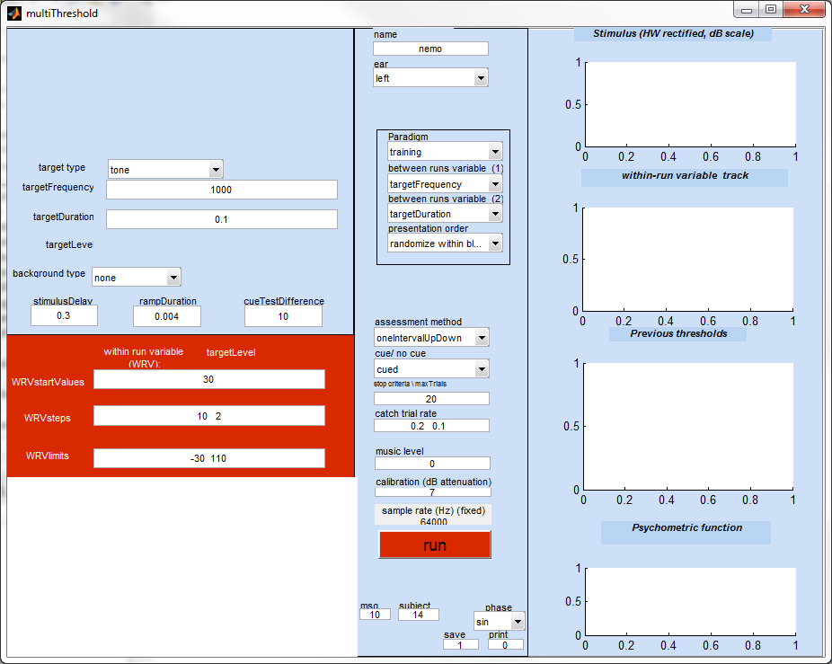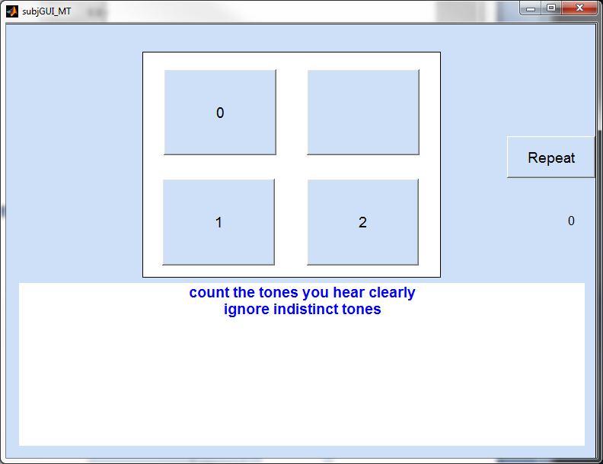
The starting value for the target tone level is 30 dB SPL. This is ideal for normal hearing because it is clearly above threshold. For impaired listeners this value should be set at a much higher level. It is important not to start with a target that is effectively silent to the patient.

Absolute threshold (‘abs Threshold’)
This assesses the pure-tone threshold at a number of different frequencies using cued tones. The target duration is 0.5 s. The list of frequencies ranges from 250-8000 Hz on an octave scale. The starting level is 30 dB SPL. This must be raised if a hearing loss is suspected.
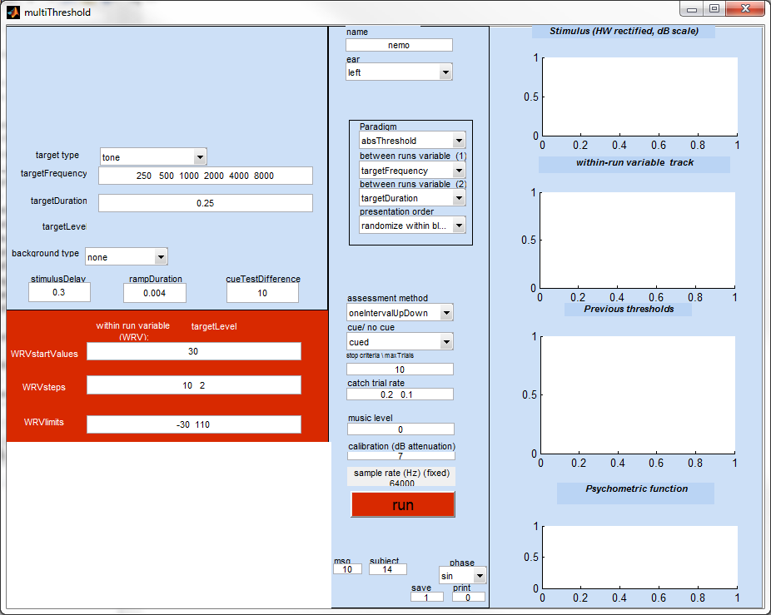

16-ms absolute threshold (‘abs threshold_16’)
The 16-ms absolute threshold is often required before measuring iso-forward masking curves (IFMCs) or temporal masking curves (TMCs). These paradigms require a 16-ms target to be set at a fixed level above its threshold. A special feature of this paradigm is that it does not specify the target frequencies. Whatever values were in the targetFrequency box are left in place. Take care to check this box and change the target frequencies if necessary.
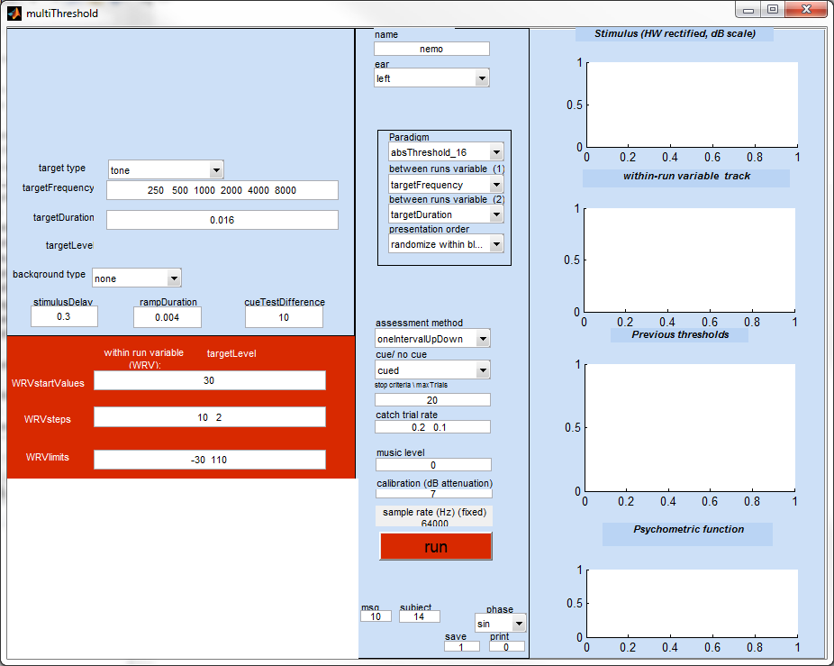

Training for forward masking paradigms
Forward masking tasks are more difficult than single-tone threshold tasks. Some guidance is needed to help the listener understand the task. The trainingIFMC paradigm is intended to facilitate this process. First, it is important to explain to the patient what he is about to hear. A diagram may be helpful to some but often a simple verbal description will help.
In the cued condition (recommended) the task is to count the number of target tones and to ignore the masker beeps. This paradigm offers favourable conditions for carrying out this task.
The parameters of the paradigm consist of a 16-ms, 2-kHz target tone preceded by a 100-ms masker tone at a range of frequencies (0.5, 0.9, 0.7, and 1.3 relative to the probe tone) with a gap of 30 ms. To minimize confusion, the masker frequency is deliberately always different from the probe tone. To further simplify discrimination between the masker and the probe, the gap between the masker and probe is 30 ms (longer than for the regular IFMC condition). The initial level of the masker is deliberately set to below threshold so that the listener can hear the probe tones at the outset of the run and can identify what exactly it is that he has to count.
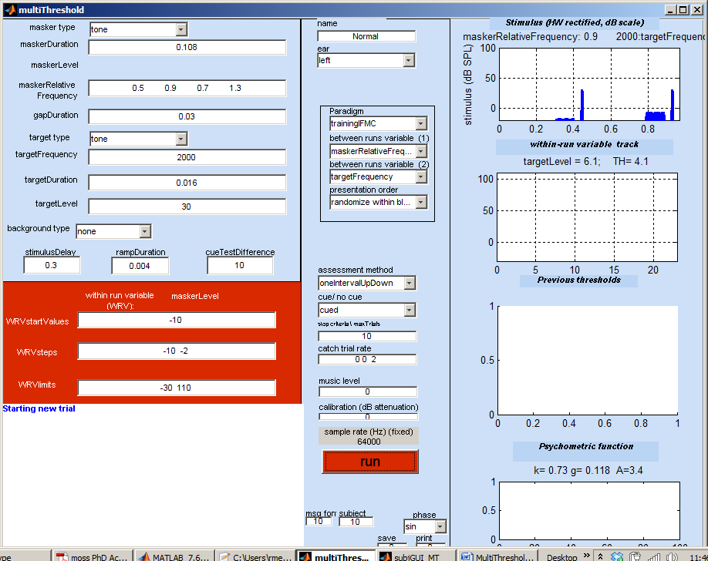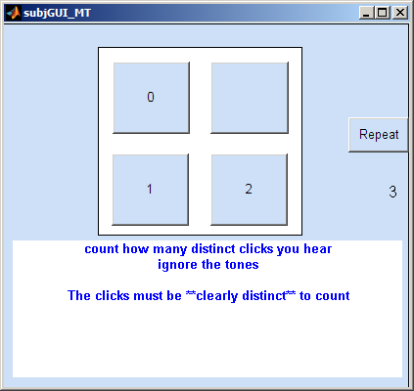
Initial confusion is normal and it is down to the clinician’s skill to guide the user’s attention to the critical stimulus feature by using such phrases as ‘listen for the click/ roughness at the end of the beep’ or ‘ignore the beeps and count the clicks’. The care taken at this stage will be amply rewarded later with smooth error free runs and rich insights into the patient’s hearing.

Iso forward-masking contours (IFMCs)
IFMCs are used to measure frequency selectivity by varying the frequency of a masker while tracking the audibility of a fixed-level, fixed-frequency target tone. The masker precedes the target by a fixed time interval of 10 ms. It is the frequency of the masker that changes between runs. The expectation in a normal listener is that the required masker level will be greater, the bigger the difference in frequency between the target and the target. This gives rise to a V-shaped or U-shaped contour for listeners with normal hearing.
The default configuration is for a 16-ms target tone at 1000 Hz. The (relative) masker frequencies vary between 0.5 and 1.3 times the target frequency. The level of the 16-ms target tone must be set to 10 dB above its threshold. The threshold for the 16-ms target can be obtained by first running the ‘abs threshold_16’ paradigm (see above). The figure shows examples of IFMCs for different target frequencies for a normal subject and for a subject with impaired hearing.
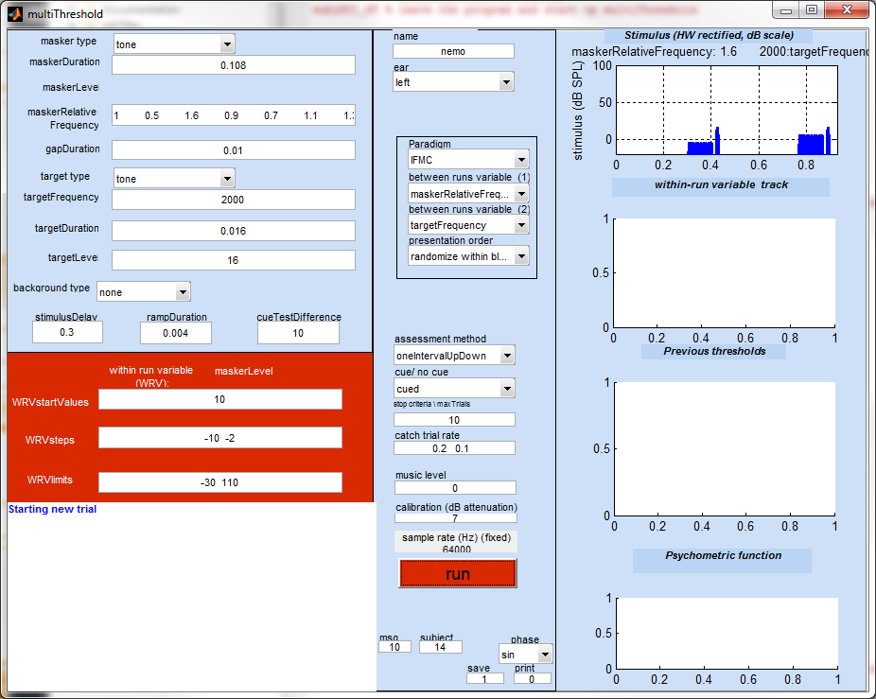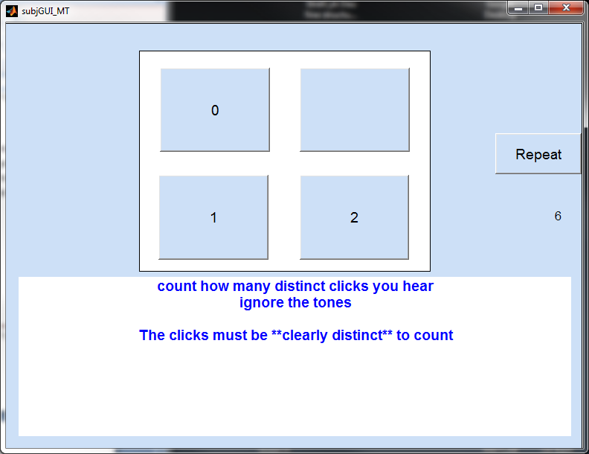
A range of target frequencies are placed in the targetFrequency box but this may be inappropriate for an inexperienced listener. In this case, replace the list with a single frequency.

These diagrams illustrate the kind of IFMCs that might be expected from normal and impaired hearing.
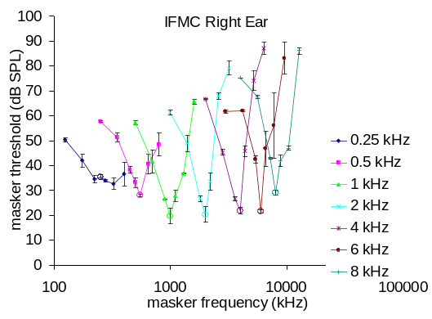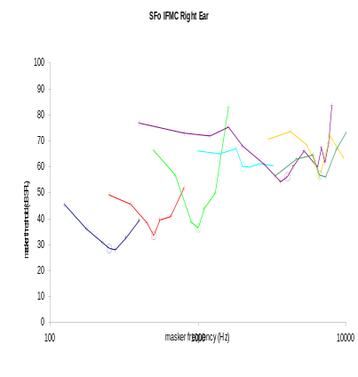
Figure 2. IFMCs. LEFT: young, male, normal subject measured using MultiThreshold. Right: a patient with high-frequency hearing loss.

Temporal masking curve (TMC)
TMCs are used to estimate auditory compression using a forward masking paradigm. In this paradigm a fixed-level target follows a masker tone and the audibility of the trailing target is manipulated by changing the level of the preceding masker. The final threshold value is the lowest level of the masker that consistently masks the fixed-level target.
After paradigm selection the targetLevel box is set to ‘NaN’ to remind the experimenter that it is his responsibility to supply this. The level of the target must be set by the experimenter prior to beginning the run. Typically, the target is set to be 10 dB above the subject’s 16-ms target threshold. The threshold for the 16-ms target should be obtained earlier by first running the ‘abs threshold_16’ paradigm (see above).
The standard stimulus is a 16-ms, 10 dB SL target preceded by a 100-ms masker. The target and masker have the same frequency (default 1 kHz) and the gap between the masker and the target is variable between runs over a range of 10-100 ms.
The targetFrequency contains a range of frequencies to explore compression over a wide frequency region. When using the paradigm for the first time, it is recommended that only on targetFrequency is used (e.g. 1000 Hz).
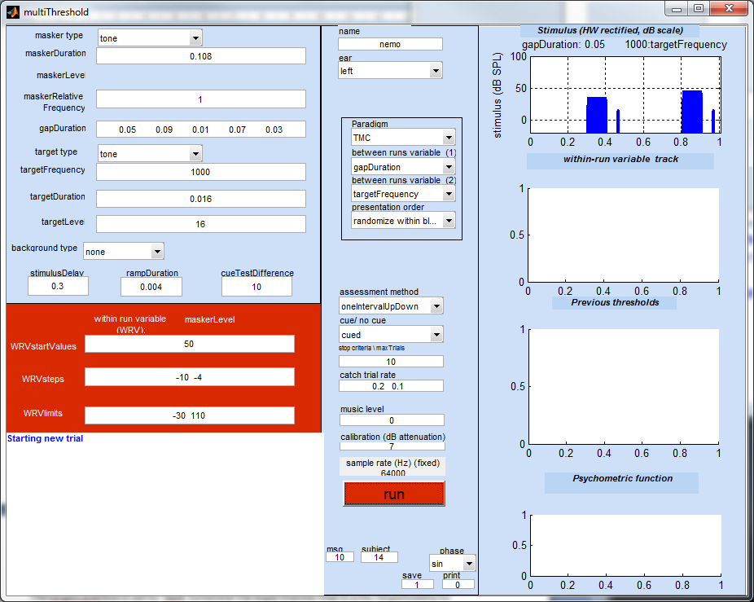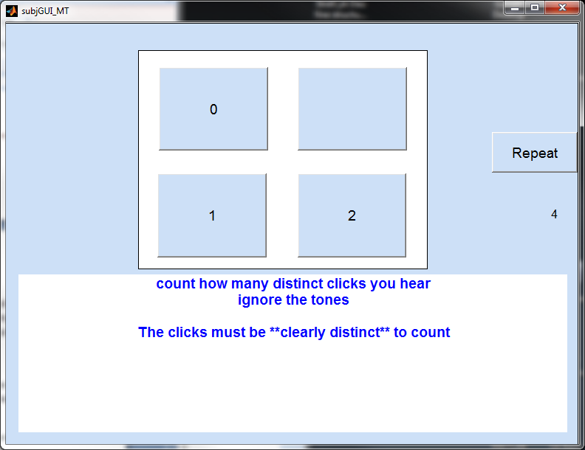
For clinical purposes, it is recommended that only one masker frequency is used. This should be the same as the target frequency and is indicated as ‘1’ in the maskerRelativeFrequency box. The slope of the TMC can be compared with typical slopes obtained from normal listeners (30-40 dB rise in masker level as the gap increases from 10-90 ms). Pathological conditions are typically grossly different and in some cases are almost flat.
If a numerical assessment of the strength of compression is required, it may be necessary to measure two TMCs using two different masker frequencies; one at the target frequency and one below the target frequency. Repeat the series but adjust the maskerRelativeFrequency accordingly.
For normal hearing, the slope of the TMC may be shallow at low signal levels and/or at high signal levels. When comparing with normal hearing use only the steepest portion of the slope. In the example below, the slope is low for gaps below 0.040 s and then becomes steeper. It is the steepest section of the function that gives most insight into the amount of residual compression
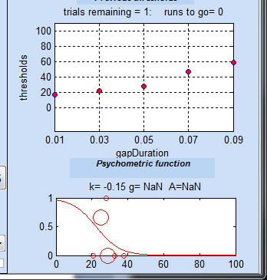 | Thresholds  gapDuration/ targetFrequency  1000  0.01 17.0791  0.03 22.3628  0.05 27.7413  0.07 47.2053  0.09 58.6248
Results of a TMC measurement

Discomfort
The level at which a 500-ms pure tone becomes uncomfortable is measured using the ‘discomfort’ paradigm. A range of different frequencies is specified as the between-runs variable. The subject’s task is to rate each stimulus as ‘comfortable’, ‘loud’ or ‘uncomfortable’. Only a single tone is presented on each trial (no cue). After each judgment, the level is raised by 3 dB. When the subject declares the tone to be uncomfortable the trial is stopped and the next trial is initiated.
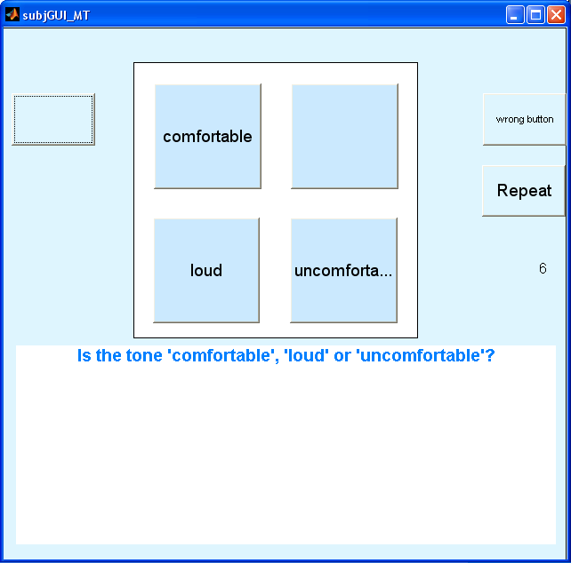
Subject GUI for the 'discomfort' paradigm

TEN test (‘TENtest’)
Pure-tone thresholds for 5-ms tones at a range of frequencies are measured against a background of threshold equalized noise (TEN). The level of the noise can be set in the box alongside the background type popup menu. Unusually raised thresholds are taken to indicate possible dead regions
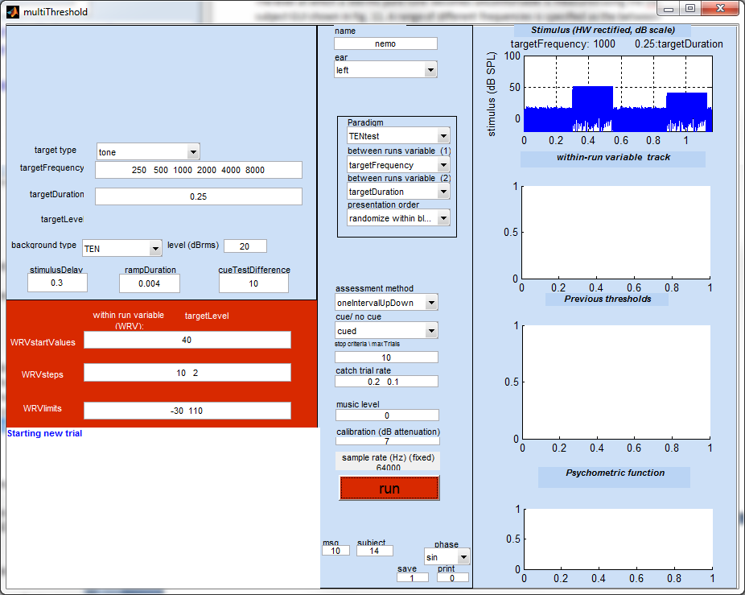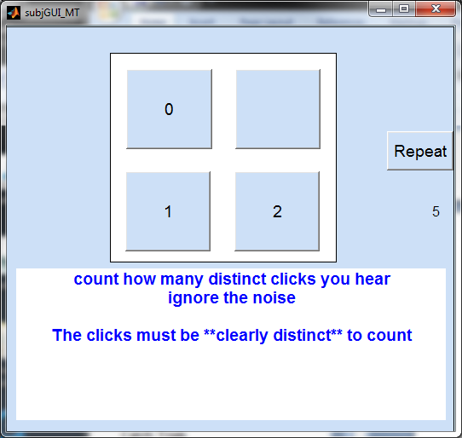

Threshold duration function (‘thresholdDuration’)
The pure-tone threshold for a 1000 Hz tone is measured at seven different tone durations between 8 and 512 ms.

Forward masking.
In this forward masking task the target tone changes in level while the masker level is fixed. This paradigm is of interest mainly to psychophysicists. The default parameter set explores four different masker levels and four different masker-target gaps
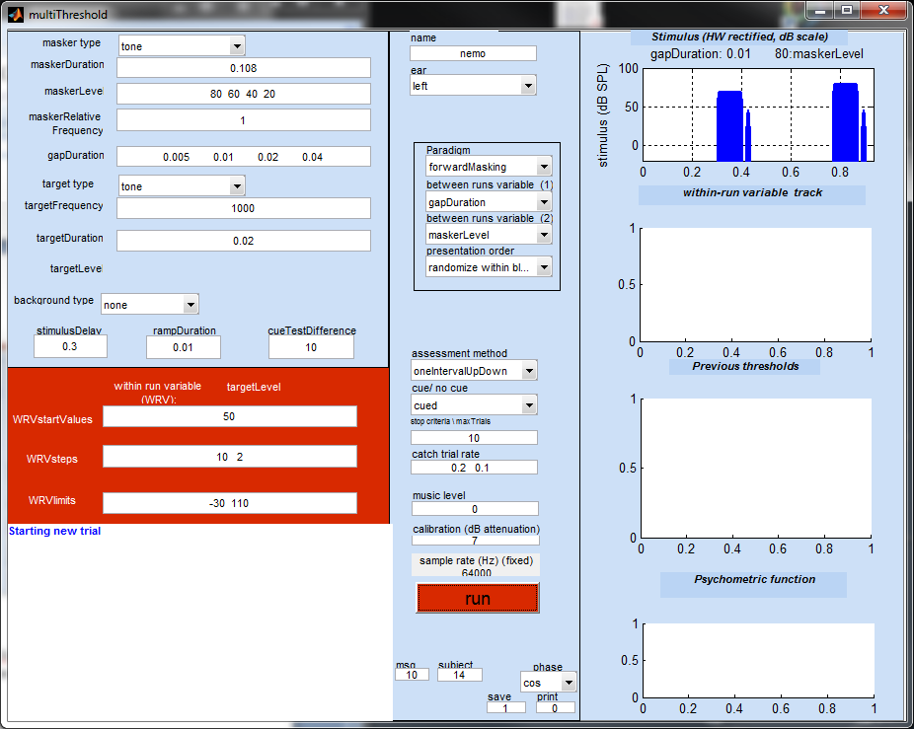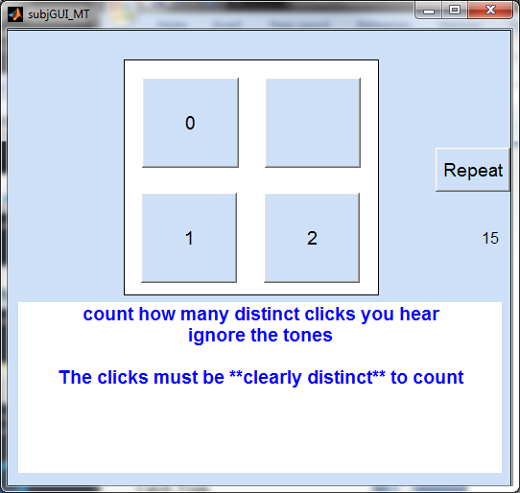

Growth of masking (GOM)
This paradigm measures the masker level just sufficient to mask a target at a number of different target levels. The maskerRelativeFrequency is set as a second between-runs variable as it is traditional to measure the function for a second masker frequency one octave below the target frequency.

Overshoot
This paradigm measures the threshold of a target when presented simultaneously with a masking tone. The target is tested twice; first when the target begins immediately after the onset of the masker and, second, when the target is presented midway through the masker. Thresholds for the target are normally higher when the target is presented at the beginning of the masker. This is also known as the ‘temporal effect’.
Notice that the two gapDurations are negative. This is because the gap specifies the time between the end of the masker and the beginning of the target. If the target precedes the end of the masker, this implies a negative gap.
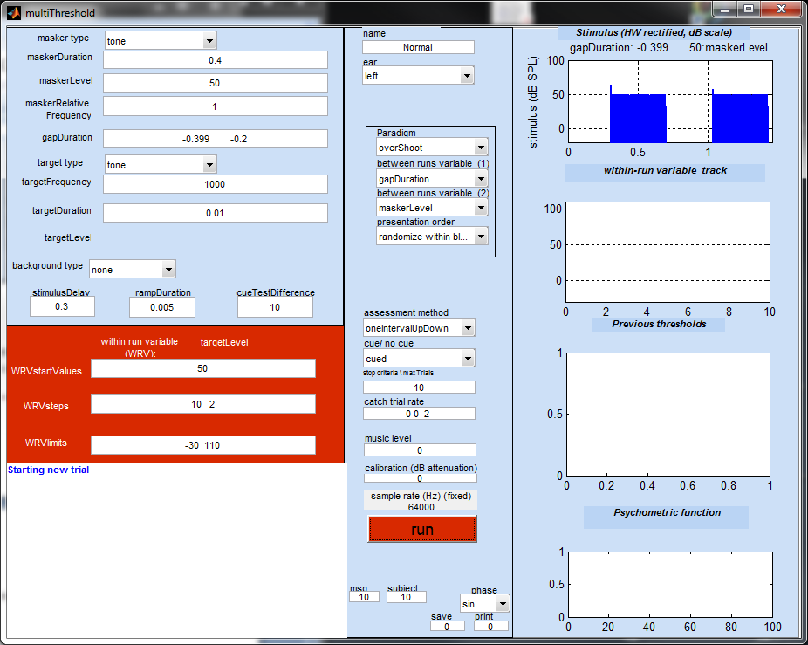
This paradigm can be modified to explore a range of interesting paradigms including backward masking (gapDuration < maskerDuration) simultaneous masking (0 < gapDuration < maskerDuration) and forward masking (maskerDuration < gapDuration) all in the same session.

User paradigms
A paradigm is defined by a MATLAB ( .m) file in the paradigms folder:
MAP1_14\multiThreshold 1.46\paradigms
To create a new paradigm, select an existing paradigm file that is most similar to the one you want to create. Save it under a new name and make the required changes to it. The name of the file must begin with ‘paradigm_’. Otherwise it will be ignored.
The name of your new paradigm will automatically appear in the paradigm popup menu in the experimenter GUI after startup.
By convention, most paradigm files begin with a call to a file, paradigmBase. This gives a value to all of the variables that need to be defined in a paradigm. These are the same values as are used in paradigm_training. This means that your new file need only contain variables that need to be changed (i.e. are different from the values in paradigmBase).
Stimulus sample rate is defined in one of the parameters in paradigmBase
stimulusParameters.subjectSampleRate=64000;
You can change the sample rate in any parameter file using this command.

Assessment methods
multiThreshold has been designed around the single/interval, cued, up/down procedure. However, two other methods are available; maximum likelihood (Green, 1993) and two-alternative forced choice. The assessment method can be chosen from the popup menu half way down the central panel.

Maximum likelihood
In many respects, this is similar to the single-interval, up/down procedure described above. The important difference is the method used to select the sequence of levels for the within-runs variable; see Green (1993) and Lecluyse and Meddis (2009) for more details. The maximum likelihood procedure converges more rapidly on the final threshold estimate but has a tendency to converge too quickly on erroneous estimates where it sticks whatever the responses of the listener. The matter is fully discussed in Lecluyse and Meddis. The inclusion of the procedure here is not a recommendation but an opportunity for comparison among traditional techniques.

Two-alternative, forced choice (2I2AFC)
The inclusion of this procedure is not recommended for profiling but is included here for the benefit of experimenters who are more familiar with this procedure and wish to compare its results with the recommended single-interval up/down procedure. Two varieties of the method are offered; ‘2I2AFC++’ and ‘2I2AFC+++’. In the first case, the tone or masker level is changed after two positive responses while, in the latter case, the change is made after three positive responses.
The measurement uses the large step size specified in WRVstepSize box until 2 reversals and then uses the small step size. The stopCriteria box contains three values; default is [75 3 5]. Here the first value is the upper limit of trials that will be allowed before the trial is brought to a conclusion. The second value is the minimum number of ‘peaks and troughs’ in the track (using small steps) to be used as the basis for a threshold estimate. The third value is standard deviation criterion used to reject a threshold estimate and continue for at least one more peak and trough in the track.
The subject GUI is slightly different for this procedure. The stimuli in the two intervals are played successively. When the first interval is presented, the button marked ‘1’ is illuminated. When the second interval is presented, the button marked ‘2’ is illuminated. The listener’s task is to choose which one contained the critical stimulus and click on the appropriate box.
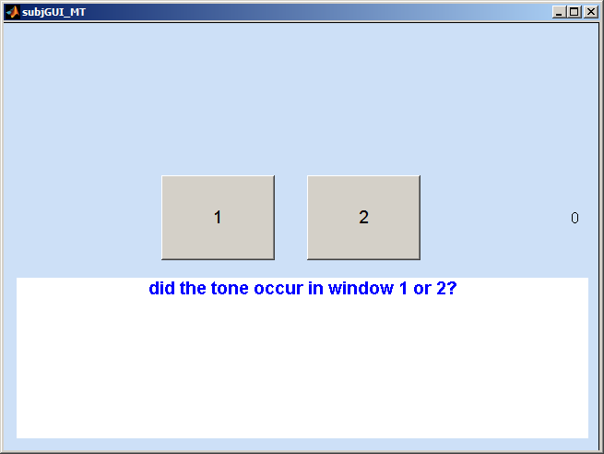

Lecluyse and Meddis (2009) compare this method with the single-interval up/down method and find that the latter is more efficient. Moreover, it was found using numerical simulations that the two-interval forced choice methods were biased low, i.e. they tend to underestimate the true threshold. This method also requires extensive training and is not suitable for clinical use. It is commonly claimed that forced-choice methods ‘control for criterion’ but there is little experimental evidence to support this view when dealing with absolute thresholds.

Statistical modeling
The ‘ear’ popup menu supplies an option to study the statistical properties of all three assessment methods using numerical simulation. Select ‘statsModelLogistic’ to study the chosen assessment method on the assumption that the listener’s responses are controlled by a logistic psychometric function. A new box will appear immediately below the ‘ear’ popup menu containing two values. The first is the threshold and the second is the associated slope of the function. These values can be edited by the experimenter. The default values are threshold=15 and slope=0.5.
When statistical modeling is used, the computer generates the responses that would normally be generated by the user. Click on run to see how accurately the procedure can estimate the ‘true threshold’ of 15. Note that the model is completely insensitive to the physical characteristics of the stimulus (frequency, duration, etc.). The response is purely dictated by a random selection from the logistic distribution.
All of the other controls on the experimenter GUI can be manipulated as usual. For example, the maximum number of trials can be varied to see how this improves accuracy.
When modeling in this way, it is normal to require many runs. This can be achieved by selecting the ‘training’ paradigm and requesting a large number of frequencies. For example the entry ‘1000:1:1005’ will generate 6 complete runs. (Remember that the physical characteristics of the stimulus are always ignored in the statistical modeling and all runs will be equivalent). The threshold estimates will appear in the message box and will also be printed out in the command window. We might reasonably expect the method to produce threshold estimates close to 15 with no upward or downward bias.
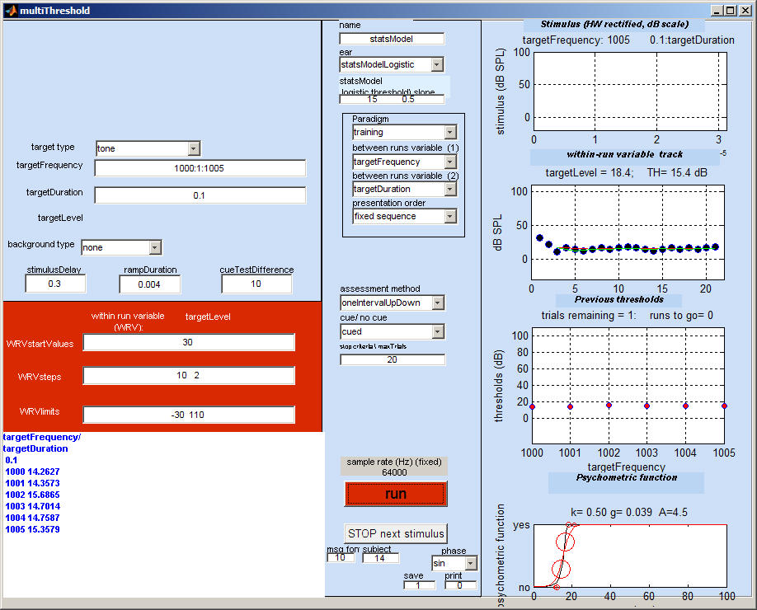
thresholds
targetFrequency/ targetDuration
0.1
1000 14.2627
1001 14.3573
1002 15.6865
1003 14.7014
1004 14.7587
1005 15.3579

Bibliography
Lecluyse, W., and Meddis, R. (2009). “A simple single-interval adaptive procedure for estimating thresholds in normal and impaired listeners,” J. Acoust. Soc. Am. 126, 2570-2579.
Green, D. M. (1993). “A maximum-likelihood method for estimating thresholds in a yes-no task,” J. Acoust. Soc. Am. 93, 2096–2105.

